Athlete Expectations
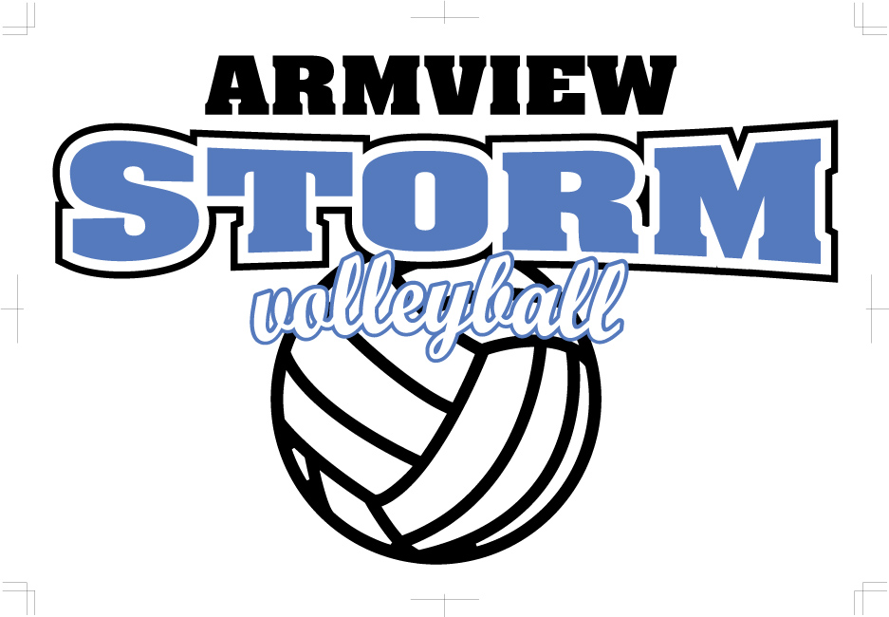
2020
In deciding to become a member of the Armview Storm Volleyball Club, the athlete must agree to meet the following standards as representatives of our organization:
- I agree to attend all scheduled practices, games, meetings and tournaments. When absence is unavoidable, a phone call to the coach will be required. Chronic absence could result in an athlete being denied an opportunity to play in the next game/tournament, or possible removal from the team.

- I agree to show respect and sportsmanship for all teammates, officials, spectators, coaches and athletes from opposing teams as well as for the rules of the game.

- I agree not to use any illegal or controlled substance (alcohol, drugs, tobacco). I understand such use will be cause for immediate dismissal from the organization.

- I agree I am solely responsible for my actions and behavior. My behavior is a reflection of my team, the club, past and future players. I will represent Armview Storm Volleyball Club in a respectful and admirable manner.

- I agree to expect a lot of myself but always settle for the best I can do today. I will learn from my mistakes but will not dwell on them in a negative way. I will look for lessons when things are tough and celebrate my and my team's successes.

- I agree to accept coaching and other directions including roster assignments in a positive, cooperative manner. If I want to question coaching decisions I will arrange to talk with the coach at the earliest time and place where a rational and private discussion can take place.

- I agree to use correct and appropriate language at all times.

- I agree to abide by any nutritional guidelines as established by my coach during tournaments.

- I agree to adhere to any training requirements as established by the coaching staff.

- I agree to embrace the cooperative nature of the sport and cheer for my TEAM and encourage them to do their best. I will play both for enjoyment as well as competition.

- I agree to protect the ability to continue using a facility by following all the rules of the facility, such as no food or drinks in gym @ ESS.

- I agree to respect and support the coaching and directing staff of Armview Storm Volleyball Club. They are volunteers and are donating their time and energy to girls’ volleyball.

Disciplinary action will be taken for failure to follow the above guidelines. These could include athletes sitting for a game, or games, suspension from the team or a set period of time, or in extreme cases, being removed from the team entirely.

Athlete:_____________________________ Date:_______________________
signature

Parent:_____________________________ Date: _______________________
signature

